**Part 1:**

**Average Rainfall Calculation**

**Pseudocode:**

1.Ask the user for the number of years.  
2. Set up variables for total rainfall and total months.  
3. Set up an outer loop that iterates across the number of years.  
4. Inside the outer loop, add an inner loop that iterates 12 times (one for each month).  
5. For each iteration of the inner loop, prompt the user to enter the rainfall for that month.  
6. Add the rainfall to the total amount.  
7. After both loops, compute the total number of months.  
8. Determine the average rainfall per month.  
9. Display the total number of months, total precipitation, and average rainfall.

**Source code:**

# Part 1: Average Rainfall Calculation

# Ask the user for the number of years

years = int(input("Enter the number of years: "))

# Initialize total rainfall and month counter

total_rainfall = 0

total_months = 0

# Outer loop for each year

for year in range(1, years + 1):

print(f"\nYear {year}:")

# Inner loop for each month (12 months)

for month in range(1, 13):

rainfall = float(input(f"Enter the rainfall (in inches) for month {month}: "))

total_rainfall += rainfall

total_months += 1

# Calculate the average rainfall

average_rainfall = total_rainfall / total_months

# Display the results

print(f"\nTotal number of months: {total_months}")

print(f"Total inches of rainfall: {total_rainfall:.2f}")

print(f"Average rainfall per month: {average_rainfall:.2f} inches")

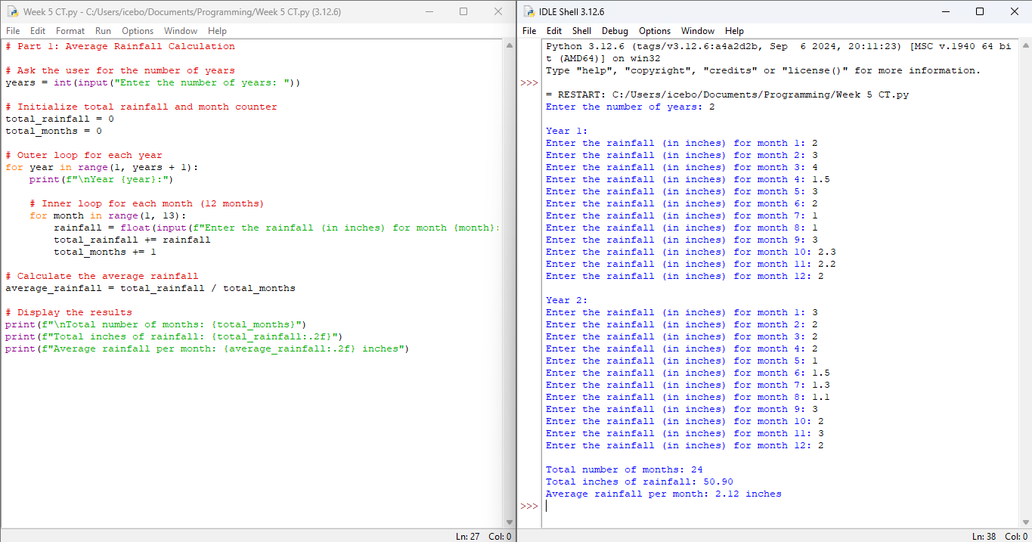**Screenshots of the application executing the code:**

**Part 2:**

**Book Club Points Award System**

**Pseudocode:**

1. Request that the user provide the number of books they purchased this month.

2. Use if statements to determine points based on the amount of purchased books.

3. Display the points awarded.

**Source code:**

# Part 2: Book Club Points Award System

# Ask the user for the number of books purchased

books_purchased = int(input("Enter the number of books purchased this month: "))

# Determine points based on the number of books purchased

if books_purchased == 0:

points = 0

elif books_purchased == 2:

points = 5

elif books_purchased == 4:

points = 15

elif books_purchased == 6:

points = 30

elif books_purchased >= 8:

points = 60

else:

points = 0

# Display the points awarded

print(f"Points awarded: {points}")

**Screenshots of the application executing the code:** 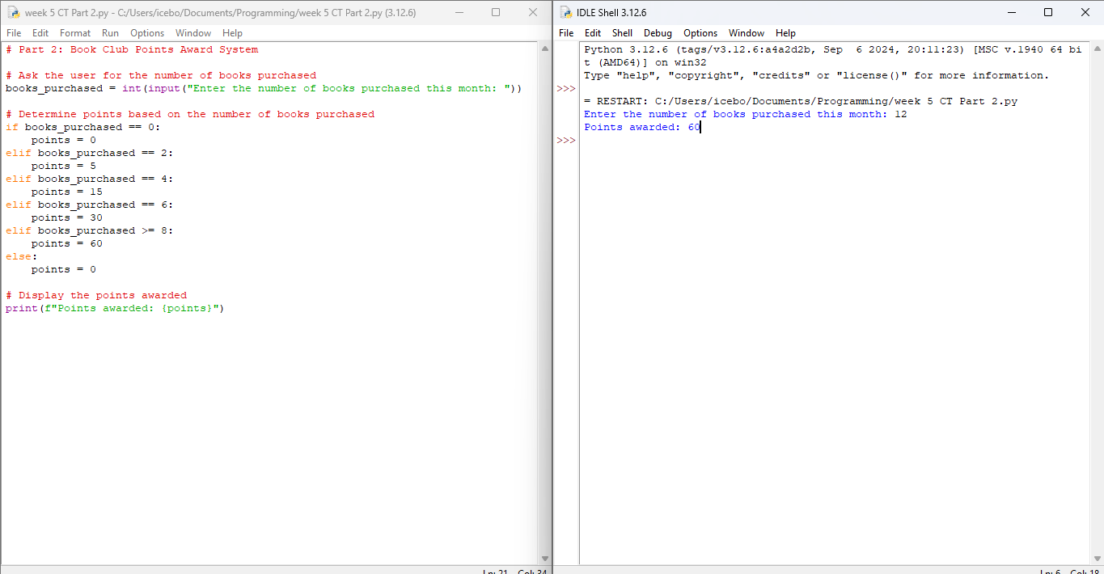

**GIT Repository link:**

https://github.com/giftataylor/Week-5-CT-Assignment-